**1. Authentication API**

**1.1.** **Login Authentication**

Purpose: Allows users to login

Method: POST

Process: Checks if email is correct -> If Valid( will provide token ) -> Returns AuthResponse which contains token.

**1.2. Login Registration**

Purpose: Allows users to register for an account

Method: POST

Process: Checks if user exist in database -> Creates a new user object -> Saves into database

**2. Stripe API**

**2.1. Checkout**

Purpose: Allows users to purchase a singular item

Method: POST

Process: Takes in ProductRequest(Price_Id,Quantity) -> Sets payment session with stripe -> Success into stripe checkout page

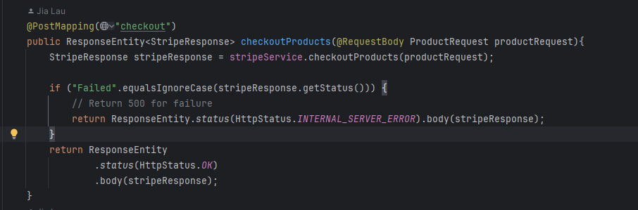

**2.2. CheckoutCart**

Purpose: Allows users to purchase multiple items (Cart)

Method: POST

Process: Takes in CartRequest(List of ProductRequest) -> Sets payment session with stripe -> Success into stripe checkout page.

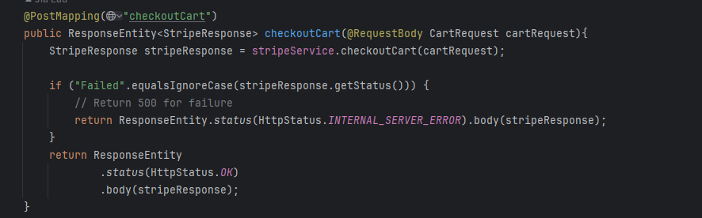

**3. DeepSeek API**

**3.1 Workout prompt**

Purpose: Generate Workout Routine

Method: POST

Process: Receives user fitness preferences, constructs AI prompt, sends to DeepSeek API, processes response, and returns structured workout plan with daily exercises, sets, reps, and training tips.

